Energy Scavenger Hunt
Name: ____________________________________________
Hr: ____________________
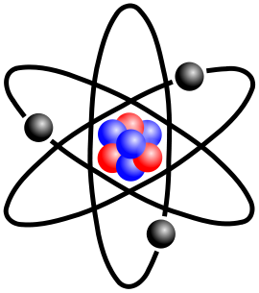

General Questions
- Label the parts of the atom in the diagram to the right

- What do we call the movement of electrons from one place
to another?

- What is “Fossil Fuel”?

- How is electricity produced from fossil fuels?

- What made Michael Faraday famous? (So famous that he is on money in other countries)

Solar Energy:
- In the Sun, Hydrogen is converted into Helium, this is called:
- What material is used in making Solar Panels? (Ex Cred – What common material is used to make solar cells?)
- Circle the parts of the US (on the map below) that use the most solar energy
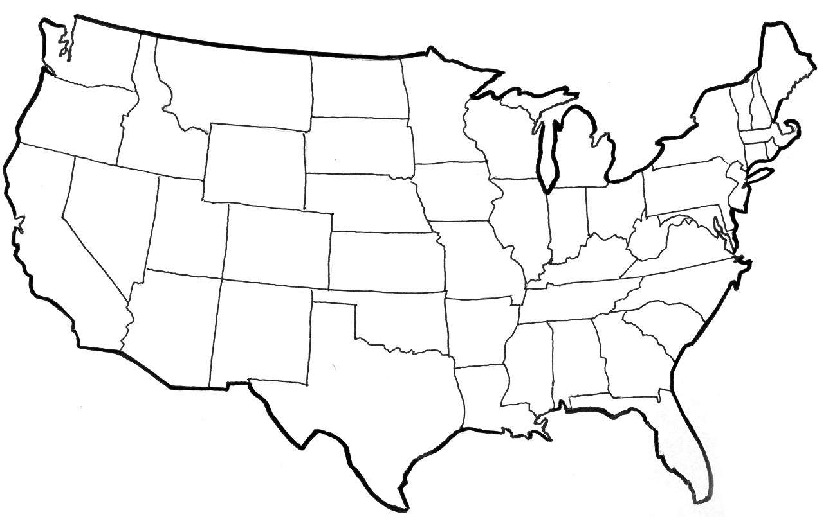

- What is “Passive Solar” house design?

Wind Energy:
- What makes the wind blow?
- *Wind turbines are being increased in height from 80meters to 100 meters. Why?

- Circle the parts of the US (on the map below) that use the most wind energy

Other types of Energy Production:
- What are the negative side effects of using Nuclear Energy?

- Biomass energy is like using Fossil Fuels in that a material is burned to produce electricity. What are the most common items burned for biomass energy generation?
- Geothermal energy : What is the temperature once you are more than 6 ft underground?
- How is Hydropower different than Tidal Power?

- Hydrogen is a gas that can be converted into electricity by using a “FUEL CELL”.
Would fuel cells be better suited for home use or for transportation? (Circle Your Answer)
Explain why! (Look this up on your own)
TRANSPORTATION
HOME

